- The rise in UK CPI inflation in April was bigger than we had anticipated, primarily due to larger once-a-year price hikes for many inflation-linked contracts and regulated prices. This development bakes in higher inflation for another year in these categories, so we now expect CPI inflation to average 3.3% in 2025, up from 3% last month.
- We expect inflation to edge up further over the coming months and peak in September. But inflation should start to fall back from October as the positive contribution from the energy category disappears, more than offsetting further stickiness in the services category.
CPI inflation rose to 3.5% in April from 2.6% in March, above our forecast and consensus expectations. April's increase was primarily driven by the energy category, which added 0.7ppts to the annual rate as Ofgem's 6.4% energy price cap hike took effect. This was bolstered by once-a-year price hikes for other inflation-linked contracts and regulated prices that were larger than expected, particularly in the services category. April's rise in services prices was also exaggerated by an usually high reading in the air fares category, as the month's collection dates coincided with the Easter holidays, unlike in 2024. RPI and RPIX inflation climbed to 4.5% and 4.2% respectively, from 3.2% and 2.8% in March.
The upward pressure from air fares should unwind in next month's data. But the bulk of April's upside surprise reflected larger increases for services where prices change once-a-year, and higher inflation is now baked in for another year in these categories. Therefore, we have raised our forecast and now expect CPI inflation to average 3.3% in 2025 and 2.5% in 2026, from 3% and 2.4% last month.
We expect headline inflation to edge upwards over the coming months, peaking at 3.8% in September. But inflation is likely to soften from October, as the positive contribution from the energy category starts to fade, more than offsetting the stickiness of services prices.
Chart 1: Larger one-off April price hikes have raised our 2025 inflation forecast to 3.3%
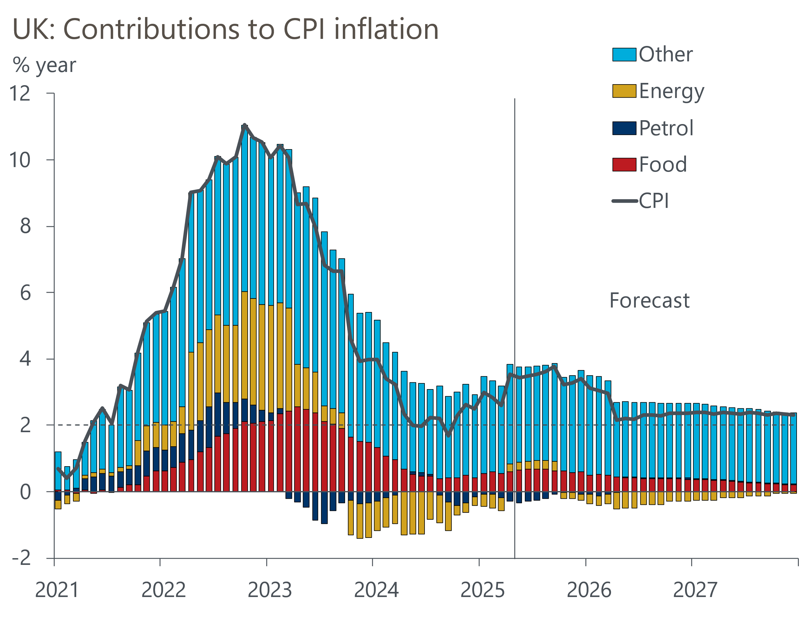
Source: Oxford Economics, Haver Analytics

